1. Login Github github.com

Create new repository

Note :

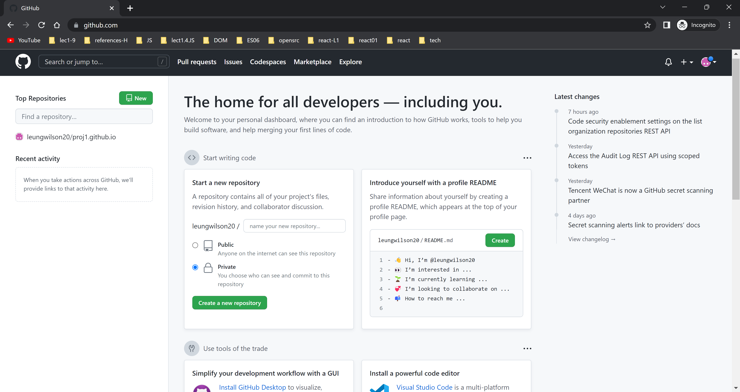

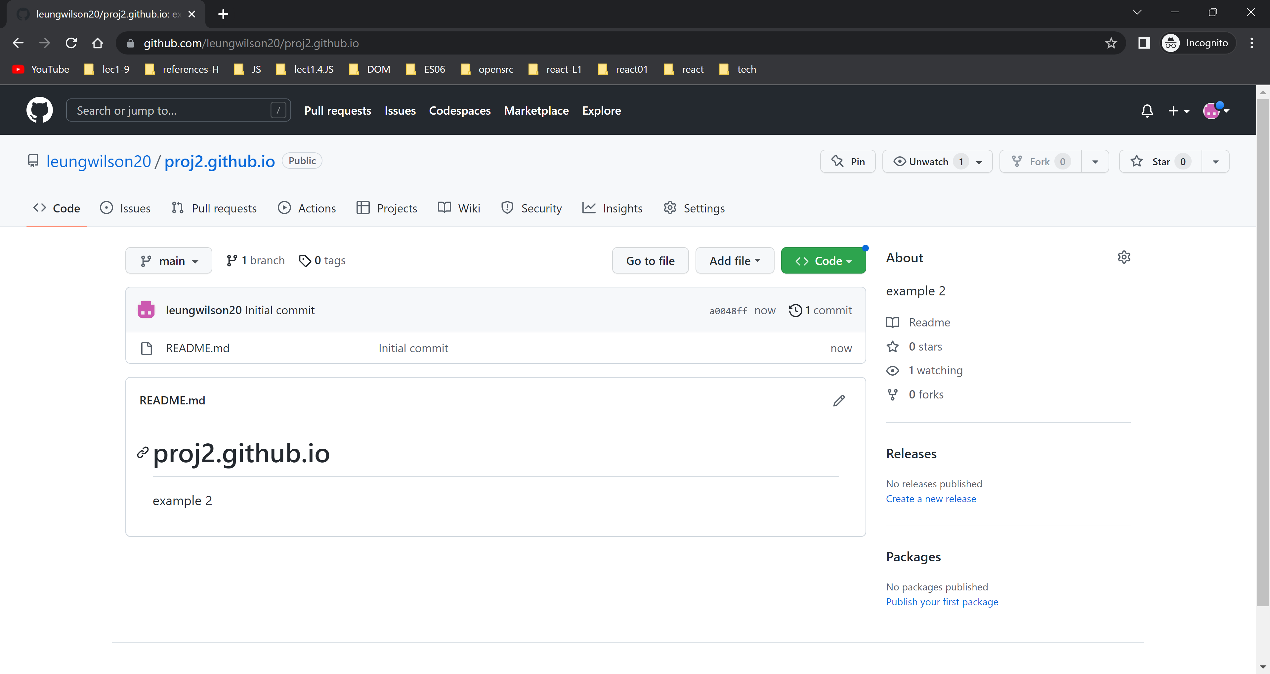

1. At local terminal

ck@Wilson MINGW64 ~

$ cd d:\react-samples

ck@Wilson MINGW64 /d/react-samples

$ cd gitexample2

ck@Wilson MINGW64 /d/react-samples/gitexample2

$ git init

Initialized empty Git repository in D:/react-samples/gitexample2/.git/

ck@Wilson MINGW64 /d/react-samples/gitexample2 (master)

$ git status

On branch master

No commits yet

Untracked files:

(use "git add <file>..." to include in what will be committed)

index.html

nothing added to commit but untracked files present (use "git add" to track)

ck@Wilson MINGW64 /d/react-samples/gitexample2 (master)

$ ls

index.html

ck@Wilson MINGW64 /d/react-samples/gitexample2 (master)

$ git branch -m main

ck@Wilson MINGW64 /d/react-samples/gitexample2 (main)

$ git add index.html

ck@Wilson MINGW64 /d/react-samples/gitexample2 (main)

$ git status

On branch main

No commits yet

Changes to be committed:

(use "git rm --cached <file>..." to unstage)

new file: index.html

ck@Wilson MINGW64 /d/react-samples/gitexample2 (main)

$ git commit -m "version 1"

[main (root-commit) 33a6389] version 1

1 file changed, 62 insertions(+)

create mode 100644 index.html

ck@Wilson MINGW64 /d/react-samples/gitexample2 (main)

$ git remote add origin https://github.com/leungwilson20/proj2.github.io

ck@Wilson MINGW64 /d/react-samples/gitexample2 (main)

$ git push -u origin main

To https://github.com/leungwilson20/proj2.github.io

! [rejected] main -> main (fetch first)

error: failed to push some refs to 'https://github.com/leungwilson20/proj2.github.io'

hint: Updates were rejected because the remote contains work that you do

hint: not have locally. This is usually caused by another repository pushing

hint: to the same ref. You may want to first integrate the remote changes

hint: (e.g., 'git pull ...') before pushing again.

hint: See the 'Note about fast-forwards' in 'git push --help' for details.

ck@Wilson MINGW64 /d/react-samples/gitexample2 (main)

$ git push -f origin main

Enumerating objects: 3, done.

Counting objects: 100% (3/3), done.

Delta compression using up to 8 threads

Compressing objects: 100% (2/2), done.

Writing objects: 100% (3/3), 922 bytes | 922.00 KiB/s, done.

Total 3 (delta 0), reused 0 (delta 0), pack-reused 0

To https://github.com/leungwilson20/proj2.github.io

+ a0048ff...33a6389 main -> main (forced update)

ck@Wilson MINGW64 /d/react-samples/gitexample2 (main)

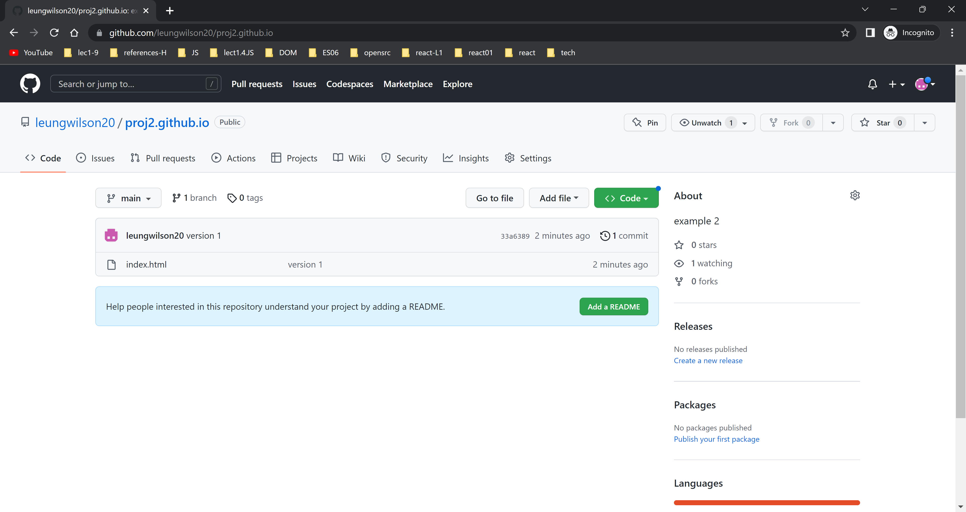

ck@Wilson MINGW64 /d/react-samples/gitexample2 (main)

$ git add Exercise5.html

ck@Wilson MINGW64 /d/react-samples/gitexample2 (main)

$ git status

On branch main

Changes to be committed:

(use "git restore --staged <file>..." to unstage)

new file: Exercise5.html

ck@Wilson MINGW64 /d/react-samples/gitexample2 (main)

$ git commit -m "add exercise 5"

[main 963dd1f] add exercise 5

1 file changed, 36 insertions(+)

create mode 100644 Exercise5.html

ck@Wilson MINGW64 /d/react-samples/gitexample2 (main)

$ git push -u origin main

Enumerating objects: 4, done.

Counting objects: 100% (4/4), done.

Delta compression using up to 8 threads

Compressing objects: 100% (3/3), done.

Writing objects: 100% (3/3), 960 bytes | 960.00 KiB/s, done.

Total 3 (delta 0), reused 0 (delta 0), pack-reused 0

To https://github.com/leungwilson20/proj2.github.io

33a6389..963dd1f main -> main

branch 'main' set up to track 'origin/main'.

ck@Wilson MINGW64 /d/react-samples/gitexample2 (main)

$

ck@Wilson MINGW64 /d/pe075ds04/2.1.11. ES6 JS VII_Extensions/exercise (main)

$ git remote -v

origin https://github.com/leungwilson20/proj02.github.io (fetch)

origin https://github.com/leungwilson20/proj02.github.io (push)

ck@Wilson MINGW64 /d/pe075ds04/2.1.11. ES6 JS VII_Extensions/exercise (main)

$ git remote set-url origin https://github.com/leungwilson20/prjo2.github.io

ck@Wilson MINGW64 /d/pe075ds04/2.1.11. ES6 JS VII_Extensions/exercise (main)

$ git remote -v

origin https://github.com/leungwilson20/prjo2.github.io (fetch)

origin https://github.com/leungwilson20/prjo2.github.io (push)

$ git push --set-upstream origin main

To https://github.com/leungwilson20/prjo2.github.io

! [rejected] main -> main (fetch first)

error: failed to push some refs to 'https://github.com/leungwilson20/prjo2.github.io'

hint: Updates were rejected because the remote contains work that you do

hint: not have locally. This is usually caused by another repository pushing

hint: to the same ref. You may want to first integrate the remote changes

hint: (e.g., 'git pull ...') before pushing again.

hint: See the 'Note about fast-forwards' in 'git push --help' for details.

ck@Wilson MINGW64 /d/pe075ds04/2.1.11. ES6 JS VII_Extensions/exercise (main)

$ git push -f --set-upstream origin main

Enumerating objects: 3, done.

Counting objects: 100% (3/3), done.

Delta compression using up to 8 threads

Compressing objects: 100% (2/2), done.

Writing objects: 100% (3/3), 1.03 KiB | 529.00 KiB/s, done.

Total 3 (delta 0), reused 0 (delta 0), pack-reused 0

To https://github.com/leungwilson20/prjo2.github.io

+ 0a5fac8...18b3537 main -> main (forced update)

branch 'main' set up to track 'origin/main'.

ck@Wilson MINGW64 /d/pe075ds04/2.1.

To publish webpages the repository name must be in the following format

***username*.github.io**

[**https://docs.github.com/en/pages/getting-started-with-github-pages/creating-a-github-pages-site**](https://docs.github.com/en/pages/getting-started-with-github-pages/creating-a-github-pages-site)

Create personal access token

